**Wifi Pineapple: Handshake Capture**

Plug the Wifi Pineapple into your device or power source

Open a web browser and navigate to 172.16.42.1:1471

Login to the Wifi Pineapple

On the left hand side of the screen there is a taskbar. Select the fourth option on the taskbar, the icon looks like a pair of binoculars. This will bring up the Recon tab.

In the middle of the screen there is a box labelled “Settings”, there is a toggle labeled “Scan” with a drop down box next to it. Select how long you want the scan to be from the drop down and select the toggle. Wait for the scan to finish.

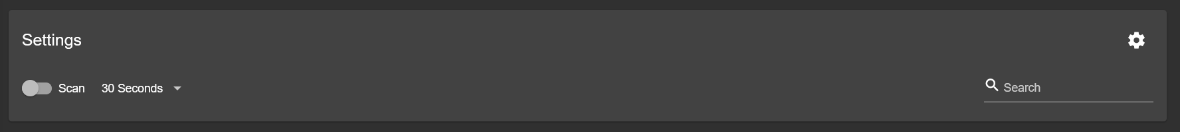

After the scan finishes, the scan results are listed in the box labelled “Access Points & Clients”. To capture a handshake, select a client and a menu will pop up. If a handshake is able to be captured, an option called “Capture Handshake” will be available. Select that option.

All the captured handshakes can be viewed by selecting the “Handshakes” tab at the top of the screen.

